

Hyper Hounds
Mini April
UKI Agility Trial

April 30 201

Hyper Hounds training facility
4284 Jaud rd
Kelowna, BC
(outdoors on sand surface)

Entries Close:
April 27

Judge:
Adele McNiven

SCHEDULE OF AGILITY
(held under UK Agility International Rules & Regulations)

CLASSES:
2 rounds of Jumpers
1 round of Speedstakes
All levels offered

Competition Manager:
Kim Boyes
hyperhounds@yahoo.ca

Trial opens:
April 8th 2015
Briefing: TBA
Judging Starts: TBA

Checks made payable to Hyper Hounds
Mail Entries with Fees to:
4284 Jaud Rd
Kelowna, BC
V1W 4C5

Trial Site & Information  DIRECTIONS  From the North: From Highway 97 go south on Dilworth Dr. Dilworth drive becomes Benvoulin rd, stay on Benvoulin rd. Go left on K.L.O rd. After the little bridge go right on Spiers rd. Follow Spiers rd until the T intersection beside the elementary school. Go left at the intersection and go straight to get onto Wallace Hill rd. Go left onto Mathews rd. Right onto Jaud rd. Follow Jaud rd around the corner, first driveway on the right after the corner is 4284. There is a wine barrel on either side of the driveway.  From the West: From Highway 97 go south on Gordon Drive. Go left on Casorso rd. When you reach the traffic circle take your first exit onto Casorso rd. At the next traffic circle take the second exit onto Casorso rd. Follow Casorso rd, stay to your left to get on to Bedford rd. At the four way stop go left. At the T intersection go left on to Saucier and then immediately right onto Wallace Hill rd. Turn left to stay on Wallace Hill Rd. Wallace Hill rd will turn into Mathews rd, stay on Mathews rd. Then turn right onto Jaud rd. Take Jaud rd around the corner, first driveway on the right is 4284. There is a wine barrel on either side of the driveway  Trial Site Rules  Exhibitors are responsible for cleaning up after their dog(s). Any exhibitor failing to do so may be excused without benefit of refund if the Trial Committee deems the exhibitor to be in violation of this requirement. Cleaning supplies and disposal sites will be available at various locations around the show grounds.  Do not allow your dog to bark excessively. This is a neighbourhood and we would like to keep our neighbours happy.  Food Services  There will be no food services available on site.  Tentative Event Schedule & Classes  Thursday evening  Jumpers round 1– Beginners & Novice, then Senior & Champion  Jumpers round 2– Beginners & Novice, then Senior & Champion  Speedstakes– Beginners & Novice, then Senior & Champion  Questions?  please contact the show manager Kim Boyes at hyperhounds@yahoo.ca | Event Time Table Thursday  Check in and measuring between 5pm and 5:45pm. First dog on the line at 6:00pm  Hotels & RV information  There is limited RV parking available on site. Contact the trial chair for details and to book a spot.  Accommodations:  HOTELS / MOTELS: All accommodations listed are approximately 15 minutes from trial site.  Please ask about dogs in the room. We have checked with these hotels but there are others who may take dogs.  Sandman (250) 860-6409 Hwy 97 across from Orchard Park, $129.75 Dog fee waived.  Town and Country Inn. 860 7121 Dogs welcome. Approx $90. Indoor pool and dog walk area.  Days Inn, Hwy 97 2649 Highway 97 N, Kelowna, BC, V1X4J6, TOLL FREE! 866-460-7456  Howard Johnson 2639 97 Hwy N, Kelowna, BC V1X4J6 Canada 1-855-290-2678  Crating  Indoor crating will be available.  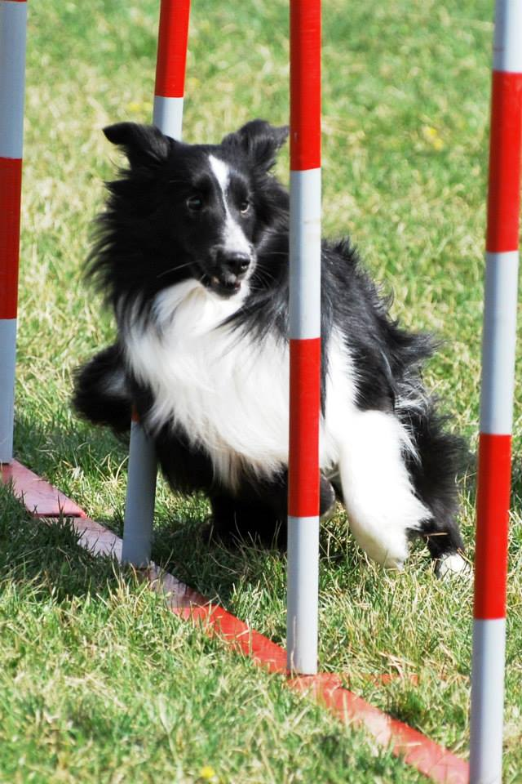

About UKI Agility
Speed Stakes Titling Program  SS Beginners: For dogs that are not eligible for SS Novice, SS Senior and SS Champion levels in the Speed Stakes Program.  SS Novice: For dogs that have gained a minimum of 12 points in the SS Beginners classes.  SS Senior: For dogs that have gained a minimum of 20 points in the SS Novice classes.  SS Champion: For dogs that have gained a minimum of 36 points in the SS Senior classes. | International Titling Program  Beginners: For dogs that are not eligible for Novice, Senior and Champion levels in the International Program  Novice: For dogs that have gained a minimum of 12 points, where 8 of those points must be obtained in agility classes  Senior: For dogs that have gained a minimum of 20 points in the Novice classes, where 12 of those points must be obtained in agility classes, 4 from jumping, and 4 from games.  Champion: For dogs that have gained a minimum of 36 points, where 12 of those points must be obtained in agility classes, 12 from jumping, and 12 from games.

UKI Jump Height
Jump Height | Dog’s Height | Long Jump maximum | A-frame Height
8 inches | 11” & under | 14” | 5’3”
12 inches | 14” & under | 20” | 5’3”
16 inches | 17.5” & under | 32” | 5’7”
20 inches | 22 & under | 40” | 5’7”
22 inches | Any | 44” | 5’7”
26 inches | Any | 52” | 5’7”
Nursery &Select only  4 inches | 11” & under | Not allowed | 5’3”

Dogs are measured while in a standing position on a flat surface . The measurement is taken from the top of the dog’s withers. All dogs, except the 26 & 22 inch divisions and the 20inch Select, must have an official measurement when at their first show. If your official dog’s measurement moves you into a different height than the one entered, you must notify the show secretary and your dog will be moved.

Entry Level / Move Up / Transfer Table to UKI
Based on highest STANDARD Agility level at time of UKI registration.
AKC/CKC | USDAA/AAC | CPE | UKI Speed Stakes  Program | UKI International  Program
Novice | Starters | Level 1, 2, 3 | SS Beginners | Beginners
Open | Advance | Level 4, | SS Novice | Novice
Excellent A | Masters | Level 5, C | SS Senior | Senior
Excellent B | MAD | ----- | SS Champion | Champion
All new dogs that have not competed at any listed organization at time of UKI registration are eligible for Beginners Level

NOTICE TO COMPETITORS

UK Agility International Rules and Regulations apply to the whole event and all people and dogs must comply with these at all times. As a competitor it is your responsibility to be aware of the rules and regulations as they stand at the time of the show. This show will run under the 2nd Edition UK Agility International rules.

All dogs and handlers must be registered with UK Agility International in order to compete. UK Agility International’s official rules & regulations are given free on registration of Handler/Owner to UKI. If you or your dog is not already registered, fill out the UKI registration form included in this schedule and add the registration fee to your entry fee.

Competitors through submission of entry acknowledge that they are knowledgeable of UK Agility International rules and regulations including but not limited to the following rules regarding entry:

Dogs under 18 calendar months of age on the day of the Show are not eligible to compete in UK Agility International Trials, with the exception of dogs over 15 calendar months of age eligible to compete in Nursery Classes & Speed Stakes.

Entries without fees paid in full will be returned. Separate entry forms must be completed by each Competitor and must be signed by the Competitor or Guardian if the competitor is a minor. Entry forms must be accompanied with the appropriate fees. If you use a recorded delivery service, you must specify No Signature Required.

Refund Policy Entries will not be accepted, changed or altered after the closing date or capping level has been reached except for the purpose of moving to a higher level. A full refund is available for any membership that is not older than 14 days from the creation of the account date. A full refund is available before the closing date or capping level is met for any show. There will be no cost if refund money is to be left in your UK Agility International account. If money is to be returned then the following administration costs will be incurred. If payment was received by check or money order then a $4 administration fee will be incurred. If payment was received by credit card a 4% charge of the refund will be assessed, per transaction. If payment was received from a Pay Pal account, a 5% charge of the refund will be assessed, per transaction. Once a show has been closed and/or capped refunds of any kind for any reason will not be available. A partial refund may be given in the event a dog is withdrawn due to injury after the closing date only if a vet letter is provided. Please contact the show management regarding this and NOT UKI.

A dog shall be withdrawn from competition without refund if it is: suffering from any infectious or contagious disease, interfering with the safety of any person or other animal or if it is likely to cause itself damage or suffering if it continues competing.

There will be no refunds for entries withdrawn and neither in the event a dog and/or handler is dismissed from the competition, regardless of the reason for dismissal providing this was within accordance of UK Agility International rules and regulations.

It is the competitor’s responsibility to be available for their class and running order. Handlers working more than one dog in a class must ensure that the dogs compete in the sequence in which they are drawn. Failure to do so will result in elimination.

It is expressly understood that Competitors alone are responsible for the behavior of their dogs, children and guests. Any competitor whose dogs, children, or guests create unnecessary disturbances or repeatedly engage in unsafe or disruptive behavior, may at the discretion of the show management, be asked to remove the offending dogs, children, guests from the event grounds. No refunds of fees will be made in such a case.

No person shall carry out punitive correction or harsh handling of a dog at any time within the boundaries of the show.

Should a judge be unable to fulfill the appointment to judge, the show management reserves the right to appoint another judge. Should circumstances so dictate the show manager, in consultation with the Judges, may alter arrangements as necessary. Such changes and the circumstances surrounding them must be reported to UK Agility International. In the event of abandonment of the show through circumstances beyond our control, the SHOW MANAGEMENT may defray such expenses from the entry fee to cover the cost of the show preparation. These accounts will then be made public.

All competitors MUST clean up after their dogs at all times. Failure to do so will result in competitors being asked to leave the Show.

Dogs left in hot cars, or dogs appearing to be in distress, will be dealt with as seen fit by the Show Management.

Returned checks do not constitute a valid entry. There will be a $25.00 service charge for returned checks. Payment of entry fees and service charges shall be made before a competitor may compete. Any unpaid fees or shortfalls to a UK Agility International account must be paid prior to the start of the event. Any fees not received within 30 days of notice shall be reported to UK Agility International. UK Agility International will suspend a dog’s/handlers registration until fees are paid in full. If your UK Agility International account owes money when we process the entries for this show your running orders may be withheld to encourage you to visit the secretaries tent at the show so that the account balance can be resolved.

All dogs are entered at this show at their owners risk and whilst every care will be taken the show management will not accept responsibility for loss, damage or injury however caused to dogs, persons or property whilst at the show.

Bitches in season may run at this show. You must notify the show secretary as early as possible to this fact. All BIS must run at the end of the class, after all jump heights have finished in that class and must use a mat on the start line, to be provided by the show. In season pants may be worn while running but handlers allow this at their own risk.

UKI Agility International Entry Form
Hyper Hounds Mini April Trial
April 30 2015

Entries Close: April 27 2015

Please fill out one handler form per handler, and one dog form for each dog entered
Handlers Name:
UKI Number:

PLEASE FILL OUT COMPLETELY AND LEGIBLY
Address:
City: Province: Postal Code:
Email: Phone:

Mail Entries with Fees to: Hyper Hounds
4284 Jaud Rd. Kelowna, BC V1W 4C5
Total Number of Class Entries __________ X $15.00
Checks Payable to: Hyper Hounds Total Enclosed

Volunteers! A trial needs volunteers to run smoothly. Please help out and volunteer whenever you can. Sign up sheets will be available all weekend.

Entry is not valid unless agreement is read and signed. Thank You for your Help!
The person who signs this agreement represents that he/she is authorized to enter into this agreement on behalf of both the exhibitor and the owner of the participating dog. In consideration of acceptance of this entry: Exhibitor/owner certifies that any and every dog they bring to this facility, whether participation or not, is not a hazard to persons, dogs, or property and assume all responsibility, liability and expenses resulting from damages causes by their dog(s). Exhibitor/owner releases UK Agility International, UK Agility Ltd, and their agents, officers & members and Hyper Hounds Dog Training and the Kelowna Dog Sports Center and will defend them and hold them harmless from all present and future loss, injury, damage, claims, demands and liabilities involving your dog, and or others equipment. Without limiting the generality of the foregoing hold harmless provisions, exhibitor/owner hereby specifically assume sole responsibility for and agree to indemnify and save aforementioned parties harmless from any and all loss and expense (including legal fees) by reason of the liability imposed by law upon any of the aforementioned parties for damages because of bodily injuries, including death, at any time in consequence of my (our) participation in the event or training, howsoever such injury or death may be caused and whether or not the same may have been caused or may have been alleged to have been caused by negligence of the aforementioned parties or any of their employees or agents or any other persons. Exhibitor/owner acknowledge all hazards presented by the training facility, event and the event premises, including but not limited to, the condition of grounds, lighting, security, measures or lack of, electrical appliances, fittings, parking areas, fences or the ability for a dog to escape from the training area, the presence of unfamiliar animals and people, the possibility of another ill animal or your own getting ill, and agility equipment; exhibitor and owner assume the risk of any harm arising from and any and all of these including allowing their dogs to run wearing collars, stop pad protectors, bitch in season pants, or any similar items. Everyone must be very careful to watch their dogs on the property, clean up after yourselves and your dogs. We reserve the right to excuse any person for what we deem excessive harshness, or any dog we feel cannot safely perform the obstacles. We reserve the right to excuse any person for what we deem as aggressive or abusive towards another person or dog.

Signature of Exhibitor/Owner or of parent or legal guardian of minor: Date:

Handler Name
UKI Number

Dog Entry Form

Hyper Hounds Mini April Trial

April 30 2015

You must submit the Handler Entry Form, (previous page) with the Dog entry Form.
Dog’s Name
UKI Number
Breed

Please tick relevant boxes.
Choose your desired competition heights. You may choose different heights for the Speed Stakes & International /Masters Series classes. You may choose to enter classes one height lower than the dog’s regular jump height (via the “Select Option”).
Speedstakes Height

8 inch

12 inch

16 inch

20 inch

22 inch

26 inch

Masters Series & International Height

8 inch

12 inch

16 inch

20 inch

22 inch

26 inch

Select Option

4 inch

8 inch

12 inch

16 inch

20 inch
Select Option

4 inch

8 inch

12 inch

16 inch

20 inch

Please tick relevant boxes. Max of 1 tick per row.
Thursday evening | Beginners | Novice | Senior | Champ |  | Cost
Jumping round 1 |  |  |  |  |  | $15.00
Jumping round 2 |  |  |  |  |  | $15.00
Speedstakes |  |  |  |  |  | $15.00

