 | Canadian Kennel Club  Official Premium List  Permission has been granted by the Canadian Kennel Club for holding this event under  Canadian Kennel Club Rules | 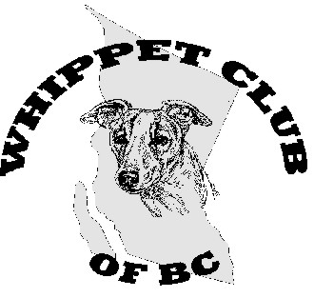

Whippet Club of BC
Is hosting
One All Breed OBEDIENCE TRIAL
and
Four All Breed CKC RALLY Obedience Trials
Mixed and unrecognized breeds may enter providing that they have a CKC identification number assigned prior to the trial

Friday February 26, Saturday February 27, and Sunday February 28, 2016
To be held indoors at the KELOWNA DOG SPORT CENTRE
3345 Bulman Road, Kelowna BC, V1Y 4N7
Ring Size 40 X 60 Feet -- Surface packed sand

OBEDIENCE JUDGE
Friday - Gwen M. Roswell, 94 720 Commonwealth Rd, Kelowna Bc

RALLY OBEDIENCE JUDGES:
Saturday - Gwen M. Roswell, 94 720 Commonwealth Rd, Kelowna Bc
Sunday – Lorraine Perron, 3924 Kekuli Court, Kelowna BC, V1Y 4E6,

WCOBC club officers and committee
President: Adele McNiven
Treasurer: Heather Ivanitz
Secretary: Carole Adley
Vice President: Fiona Hart
Trial secretary to whom all entries must be sent: Fiona Hart, 2070 KLO Road, Kelowna, BC, V1W 2H7, 250 862 2706
Trial chairperson: Carole Adley
Committee: members of the WCOBC

CKC Executive Director Lance Novak
CKC board Director Zone 12 - BC Interior & Yukon, Russel (Sandy) Fletcher diplomat@telus.net
CKC head office 200 Ronson Dr, suite 400 Etobicoke Ont, M9W 5Z9
Obedience rep for BC Interior and the Yukon. Gwen M. Roswell, 94 720 Commonwealth Rd, Kelowna Bc, V4V 1R7, (250) 766-4943

Early Bird Entries open January 25, 2016 --- Close of early Bird Entries – February 16, 2016
One hour prior to the start of the trial, “Day of” entries accepted for an additional late entry fee.
Please do not send an entry that requires our trail secretary to travel to the post office to sign for the receipt
as this does not ensure that your entry will be received on time.
There are no refunds on overpayment. Confirmations of early bird entries will be emailed after closing date.

OBEDIENCE CLASSES (see page 2 for more info on classes)
Pre Novice, Intermediate Novice, Novice A, B, and C, Open A and B, Utility A and B
RALLY OBEDIENCE CLASSES
Novice A and B, Intermediate, Advanced A and B, Excellent A and B. (For dogs seeking RAE enter Advanced B and Excellent B)
List of Awards and Prizes
- Qualifying ribbons will be awarded for all dogs receiving a qualifying score.
- Rosette and High in Trial certificate for the highest scoring dig in the obedience trial/
- High in Class rosette for each class except Pre-Novice.
- Prize for High score whippet in each trial.
- This is a qualifying event for whippets gathering credits toward the Whippet Club of BC Versatility award of 2016. For more details on this award contact Adele at wcobc@shaw.ca
BOOSTERS
Saturday - Trial 2 RALLY NOVICE - Prize for High score Novice dog. Donated by Happy Heelers
Sunday - Trial 3 RALLY OBEDIENCE - Prize for high score CCN dog
RALLY OBEDIENCE - Prize for aggregate high score dog entering all four Rally trials

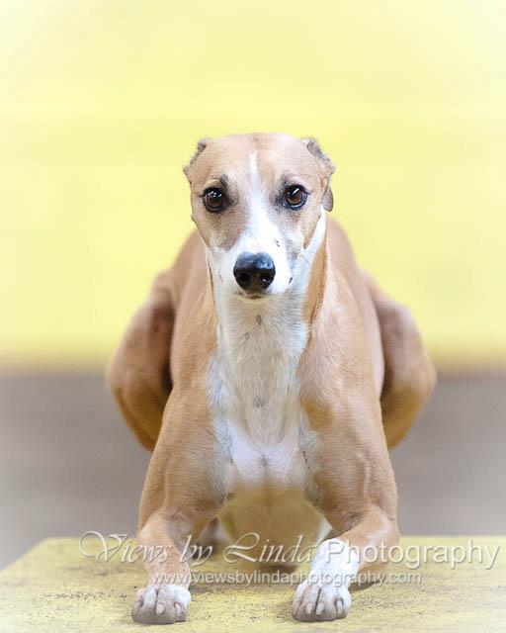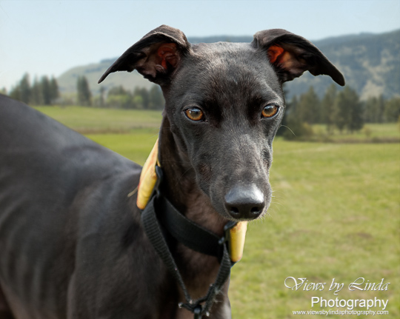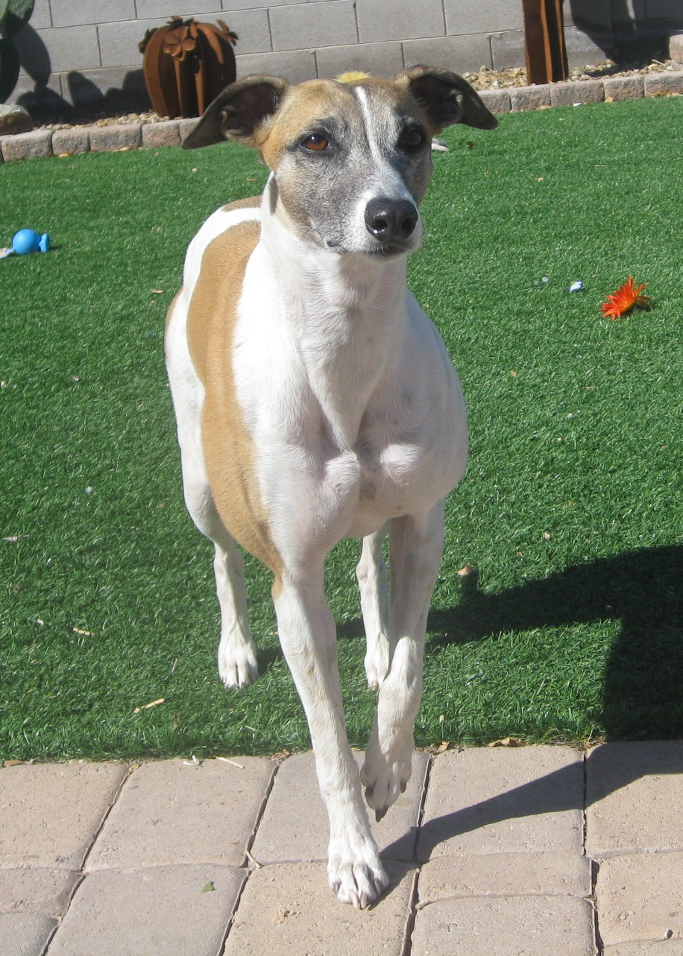

The Rally Obedience trials will have two alternating rings.
If your classes are complete and you are able to stay and help out, it will be appreciated.

Sign up for your Canine Companion Number
To compete, mixed-breed and unrecognized-breed dog owners

must apply for a Canine Companion Number (CCN)
and meet specific criteria as set out in the
Canine Companion Club Policy.
Applications for a CCN number can be submitted to
CKC information@ckc.ca.
For more information, contact our Member Services team Department
at 416-674-3699 or 1-855-DOGS CKC
(1-855-364-7252) Visit www.ckc.ca for applications

ELECTIVE CLASS INFORMATION
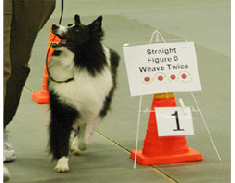
Note: 2015 brought in a new Rally class called Intermediate. It is an OPTIONAL class that uses signs # 1 to 118 and is performed ON LEASH with no jump incorporated. Earning a title in Intermediate is not a requirement to enter Rally Advanced

OBEDIENCE PRE-NOVICE
The Pre-Novice Obedience class is optional and earning a title is not a requirement to enter Novice Obedience.

OBEDIENCE NOVICE C – scores earned by dogs in Novice C are not eligible for High in Trial

OBEDIENCE NOVICE INTERMEDIATE is an optional class and earning a title is not a requirement to enter Open Classes.

- To be eligible to compete in a obedience or rally trials, a dog must be 6 months of age and be registration with the CKC, with an Event Registration Number (ERN), a Performance Event Number (PEN), a CKC Miscellaneous Certificate if it belongs to a CKC listed breed, or a Canadian Companion Number (CCN) all of which can be obtained by contacting CKC at www.ckc.ca
- Spayed bitches, debarked dogs, and neutered males are eligible to participate.
- Bitches in season may not compete. When a bitch comes into season after the entry has closed a Veterinarian’s certificate, certifying the bitch was in season within the 10-day period preceding the trial must reach the secretary on or before the start of the trial. A full refund of entry fees and listing fees will be given. .

DETAILS AND INFORMATION ABOUT OUR FACILITY – KELOWNA DOG SPORT CENTRE
Precincts of the trial are the barn and parking area. Other areas are out of bounds.
Parking is along side the red barn ONLY. (facing south)
Form two rows leaving enough room for the vehicles parked against the barn to back out easily.
These trials are being held in a dog training centre that is only partially heated. Be prepared for winter conditions.
There is non heated crating room in the building along the concrete walk way. Very limited power.
Porta Potty on site.
This facility is in the middle of a turf farm. Please do not let your dogs onto the farm whether it looks like turf or not.
There is no off leash area at this trial site. But there is a dog park only five minutes away. Ask for directions.
Please pick up after your dog.
Other information – GENERAL, CKC
- 19.6 Any person, either within or outside the judging ring, who does anything calculated to attract, distract or otherwise interfere in any way with the attention, deportment, or performance of a dog under judgment, may be disciplined by the Discipline Committee in whatever way it considers to be in the best interest of the club, or the judge may take summary action.
- 19.7 It shall be the duty and obligation of the trial-giving club to see that a judge, club official, ring steward, volunteer, or competitor at an Obedience Trial held under these regulations, is not subject to indignities of any kind. The Obedience Trial Committee Chair shall promptly report to the CKC any infringement of this regulation, and the Discipline Committee shall have the authority to take such action as it deems fit on receipt of a report indicating that this has occurred. A copy of this regulation shall be prominently placed in every premium list and catalogue.
- Non Member Participation Fee will apply to dog owners wishing to receive titles for their dogs if they not CKC members $57.60 + HST. A non member participation fee will be charged to a resident of Canada who is a non-member of the CKC. The non member participation fee is paid in any year a title is earned and covers all titles and dogs owned by that individual. In order for the title to be awarded, the non member will have a choice to either become a CKC member or pay the non member participation fee. Failure to comply within 30 days of notification will result in the title being withheld and the dog cannot be moved up to the next level.
All Premium Lists will carry a note stating the fee applies only to dogs wholly owned by non-member residents of Canada and is not applicable to CKC members.

Early Bird Entry Fees | “Day of “ Entry Fees
Obedience = $30.00 | Obedience = $35.00
Rally Obedience = $27.00 per event | Rally Obedience = $32.00 per event
RAE entry (second entry) = $22.00 | RAE entry (second entry) = $27.00
Listing Fees = $9.40 | Listing Fees = $9.40

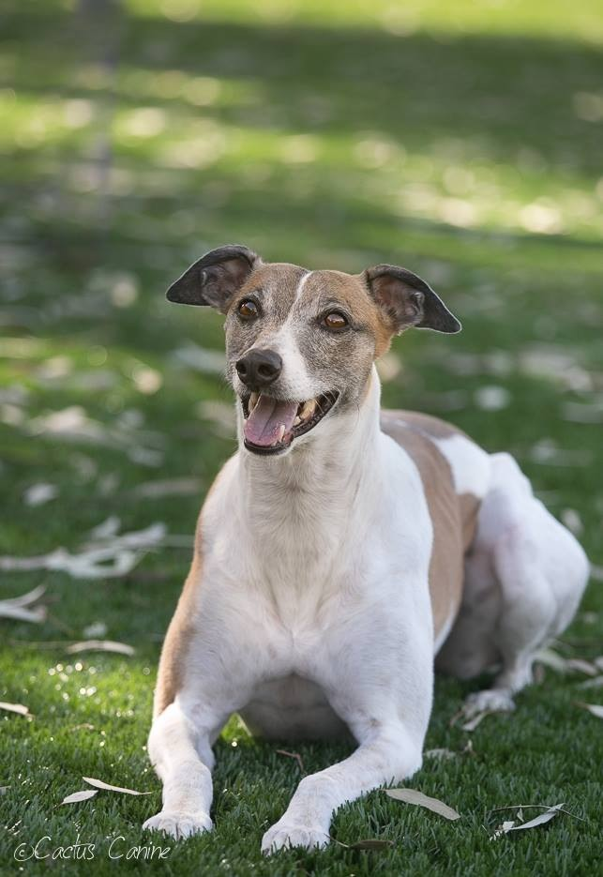
Obedience EARLY BIRD ENTRIES CLOSE
February 16, 2016
Rally Obedience EARLY BIRD ENTRIES CLOSE
February 17, 2016

To Pay
Please Make cheques payable to WCOBC
Mail to
Fiona Hart, 2070 KLO Rd, Kelowna BC V1W 2H7
OR.
Email entry form to wcobc@shaw.ca and pay via PayPal to wcobc@shaw.ca
If using PayPal Add 3% processing fee.
Include note regarding dog’s name and entry details

One OBEDIENCE TRIAL
And Four CKC RALLY OBEDIENCE TRIALS
Official Entry Form
Obedience EARLY BIRD ENTRIES CLOSE
February 16, 2016
Rally Obedience EARLY BIRD ENTRIES CLOSE, February 17, 2016
Official Canadian Kennel Club Entry Form

Click the boxes, enter your information, print and send with payment to:

Registered Owner Owner’s CKC #
Complete Address
Telephone Email Address
Handler
DOG’s Call Name BREED
DOG’S REGISTERED NAME
DOG’s Date of Birth M D Y SEX HEIGHT at WITHERS inches
DOG’S NUMBER ID TYPE: CKC Reg. # CKC ERN # PEN # CCN LISTED #
Dog’s Place of Birth: Canada Elsewhere

BREEDER:
Acknowledgements will be sent via email whenever possible
SIRE:
DAM:
DOG’s JUMP HEIGHT: under 10”at withers = 6” , 10”–15”.= 8” , 15”– 20”= 12” , over 20”=16”

CLASS (click on appropriate box)
OBEDIENCE  Trial 1 Friday | Trial 1 Saturday  Judge: Roswell | Trial 2 Saturday  Judge: Roswell | Trial 3 Sunday  Judge: Perron | Trial 4 Sunday  Judge: Perron
Pre Novice | Novice A | Novice A | Novice A | Novice A
Nov Intermediate | Novice B | Novice B | Novice B | Novice B
Novice A | Intermediate | Intermediate | Intermediate | Intermediate
Novice B | Advanced A | Advanced A | Advanced A | Advanced A
Novice C | Advanced B | Advanced B | Advanced B | Advanced B
Open A | Excellent A | Excellent A | Excellent A | Excellent A
Open B | Excellent B | Excellent B | Excellent B | Excellent B
Utility A
Utility B

I CERTIFY that I am the registered owner (s) of the dog, or that I am the authorized agent of the owner (s), whose name (s) I have entered above, and accept full responsibility for all statements made in this entry. In consideration of the acceptance of the entry, I (we) agree to be bound by the rules and regulations of the Canadian Kennel Club, and by any additional rules and regulations appearing this premium list.

see payment chart page 3 Total payment $

Paid via: Cheque PayPal Money Order

WCOBC Toonie Coupons included # of coupons

SIGNATURE _________

WCOBC exhibitor WAIVER
Must accompany ALL entries

- I acknowledge that I, as exhibitor, handler and patron, know and abide by the “CKC Dog Show Rules”, and that I am familiar with their content.
- I agree that the Club holding this Show has the right to refuse this entry for cause, which the Club shall deem to be sufficient.
- In consideration of the acceptance of this entry and of the holding of the Trials and of the opportunity to have the dog judged and to win ribbons or trophies.
- I agree to hold the Whippet Club of BC, their members, directors, governors, officers, agents, superintendents, or show secretary and/or the owner or lessor of the premises, and any employees of the aforementioned parties, harmless from any claim for loss or injury which may be alleged to have been caused directly or indirectly to any person or thing by the act of a dog while in or upon the show premises or grounds or near any entrance thereto, and I personally assume all responsibility and liability for any such claim, and I further agree to hold the aforementioned parties harmless from any claim for loss of a dog by disappearance, theft, death or otherwise, and from any claim for damage or injury to the dog, whether such loss, disappearance, theft damage or injury be caused or alleged to be caused by the negligence of the Club or any of the parties aforementioned, or by the negligence of any other person, or any other cause or causes.
- I hereby assume the sole responsibility for and agree to indemnify and save the aforementioned parties harmless from any and all loss and expense (including legal fees) by reason of the liability imposed by law upon any of the aforementioned parties because of bodily injuries including death at any time resulting there from, sustained by an person or persons, including myself, or on account of damage of property, arising out of or in consequence of my participation in this show, howsoever such injuries, death or damage to property may be caused and whether or not the same may have been caused and whether or not the same may have alleged to have been caused by negligence of the aforementioned parties or any of their employees or agents, or any other person.

Date____________________________ Signed______________________________________

___________________________________________________________________
Print name.

Print Dog’s name:

Thank you

To Pay
Please Make cheques payable to WCOBC
Mail to
Fiona Hart, 2070 KLO Rd, Kelowna BC V1W 2H7

OR.
Email entry form to wcobc@shaw.ca and pay via PayPal to wcobc@shaw.ca
If using PayPal Add 3% processing fee.
Include a note to reference your entry.

